CS 6327 Video Analytics Assignment 3

Instructor: Dr. B. Prabhakaran TA: Kanchan Bahirat

**Due – March 10th, 2017**

**Description:**

Microsoft Kinect provides a color and depth information of the scene. Using Microsoft Kinect, we have captured a sequence of depth and color frames showing the scene that has two balls (orange and purple colored balls) rolling on the floor.

For this assignment, we will provide you:

* Color and depth frames - an initial and a final frames of the sequence - obtained from Kinect, along with time instants of capture.
* Camera intrinsic matrix for RGB camera,
* Inverse of camera intrinsic matrix of the depth camera and rotation matrix between RGB and depth camera.

With the above data, please do the following:

1. Using these matrices, find a corresponding color for each pixel in the depth image. This will generate a colorized depth image.  In the colorized depth image, draw bounding boxes around the **two** balls. You will need to generate colorized depth image (and draw boinding boxes) for both initial and final set of frames.
2. Color and depth frames give you the initial and final position of two balls. Based on that and calibration parameters, you have to compute their *relative velocity* in **milimeters/seconds.**

**Depth Image:**

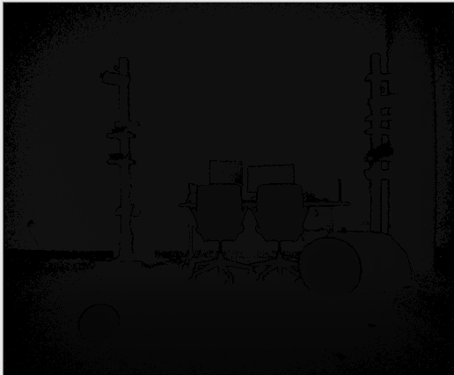

**Color Image**



**Colorized Depth Image**

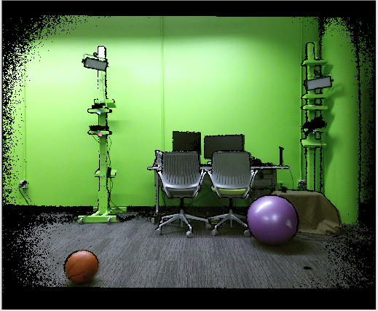

This assignment will require a good understanding of intrinsic matrix, rotation/translation between two coordinate systems. It will help you to understand the mapping between 2D-3D. It will also require to implement the code for vector to matrix multiplication in order to apply transformations to a point.

All the images and files for transformations will be made available at eLearning.

**Where to submit the assignment:**

eLearning (and Only eLearning)

**Late Submissions:** **Accepted.** However, there will be a penalty when you are late.

**Rubrics:**

Colorized depth image generation – 40 points.

Marking the bounding box around both the balls -- 10 points

Computing the relative velocity of balls in mm/sec -- 50 points